Avon Gardens Trust
Eastleach House Garden, Eastleach Martin Cirencester, Gloucs. GL7 3NW on Wednesday 17 July

A private visit to Eastleach House, Cirencester @ 2pm, followed by tea and cake at the nearby Victoria Inn.

This extensive stunning garden is not open to the public, but we will be introduced to the garden by the owners before we have a self guided tour of the grounds.
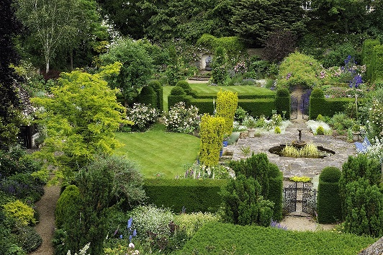
The Garden, covering 14 acres, is made up of many parts and has many surprises, a tour takes about 1 1/2 to 2 hours.
The south lawn features a croquet lawn, a long, raised border, terraces covered in vines and a short line of laburnums

Entering the Park, the first view visitors get from the house is of the stag silhouetted against the distant sky and this sets the tone for further surprises in a garden of great variety and contrast. The Park covers about 10 acres and it was this long vista with an avenue of Tilia platyphyllos rubra leading towards the distant view of the Marlborough Downs and the Liddington Clump on the skyline. Trees have been planted creating a traditional park of oak, beech, maple, cedar and, nearer the house, a small arboretum of choice and unusual trees has become well established. Annual cornfield wild flowers edge some of the many meandering grass paths across the slopes. Perennial wild flowers and butterflies abound in good weather. At the centre of the avenue, where a cross avenue of beech meets the lime avenue, an oval is proscribed by pleached limes in the centre of which is a roundel of yew arches (know as "hedge-henge") with a bronze stag mounted on rocks at its centre.
The Rill garden has curving paths edged with box run from corner to corner crossing the central rill over a clapper bridge. The water falls over thirteen carved stone steps, each producing a different sound effect, down to a circular pond. Three big borders on each side of the rill, planted with perennials in a colour wheel, reach their full glory from July to September. The focal point of the Rill Garden is the crescent of nine Sorbus aria lutescens
The Walled Garden was begun in 1987 with the re-building of most of the outer walls, the making of the pattern of paths, and the construction of the summerhouse and raised terrace.
From here there is a good view across the garden over the hedges of topiary and the rose arches. The structure, a pattern of paths, gives a choice of ways and different focal points to draw the visitor on.

NB: The garden includes four ponds and some steep steps and slopes
Further details may be found on their website www.eastleachhouse.com

Price - £17 for AGT members, £19 for guests.
Further details may be found on our website https://www.avongardenstrust.org.uk/events/a-visit-to-eastleach-house/ where booking forms can be obtained

